**TITLE OF LAB: (INTRODUCTION TO UNIT IMPULSE AND UNIT STEP SEQUENCES)**

**LAB # 07**



**Spring 2022**

**CSE301L Signals & Systems Lab**

Submitted by: **Safi Ullah Khan**

Registration No.: **20PWCSE1943**

Class Section: **B**

“On my honor, as student of University of Engineering and Technology, I have neither given nor received unauthorized assistance on this academic work.”

Student Signature: ______________

Submitted to:

**Engr. Durr-e-Nayab**

Day, Date (e.g Sunday, Jun 08th, 2022)

**Department of Computer Systems Engineering**

**University of Engineering and Technology, Peshawar**

**OBJECTIVES OF THE LAB**

‐‐‐‐‐‐‐‐‐‐‐‐‐‐‐‐‐‐‐‐‐‐‐‐‐‐‐‐‐‐‐‐‐‐‐‐‐‐‐‐‐‐‐‐‐‐‐‐‐‐‐‐‐‐‐‐‐‐‐‐‐‐‐‐‐‐‐‐‐‐‐‐‐‐‐‐

In this lab, we will cover the following topics:

* Generating unit impulse and unit step sequences
* Basic signal operations

‐‐‐‐‐‐‐‐‐‐‐‐‐‐‐‐‐‐‐‐‐‐‐‐‐‐‐‐‐‐‐‐‐‐‐‐‐‐‐‐‐‐‐‐‐‐‐‐‐‐‐‐‐‐‐‐‐‐‐‐‐‐‐‐‐‐‐‐‐‐‐‐‐‐‐‐

**-------------------------TASK 01--------------------------**

* Using **one’s** function; plot the **signum** sequence over interval ‐10≤n≤10. It can be defined as:

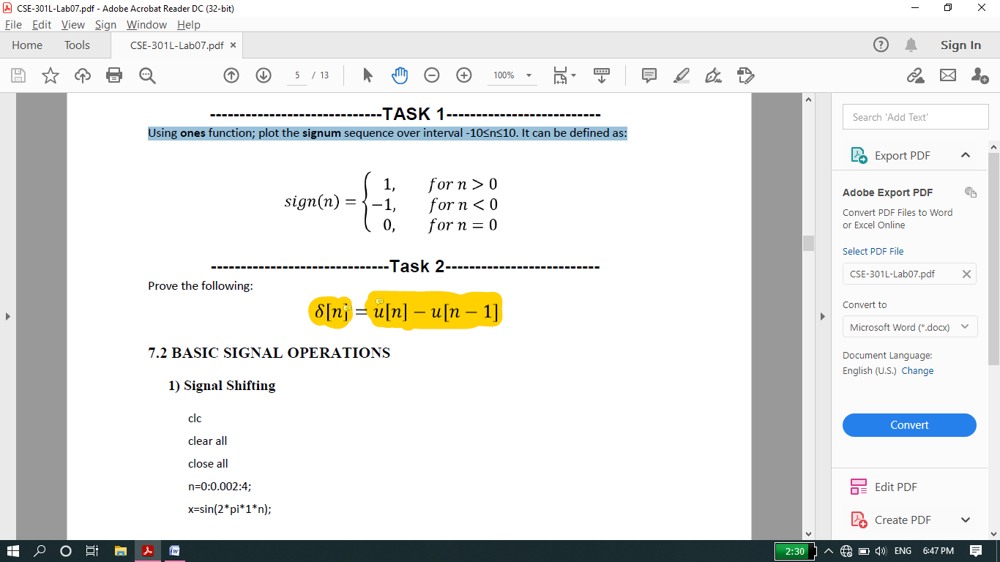

**Screenshot of Input:**

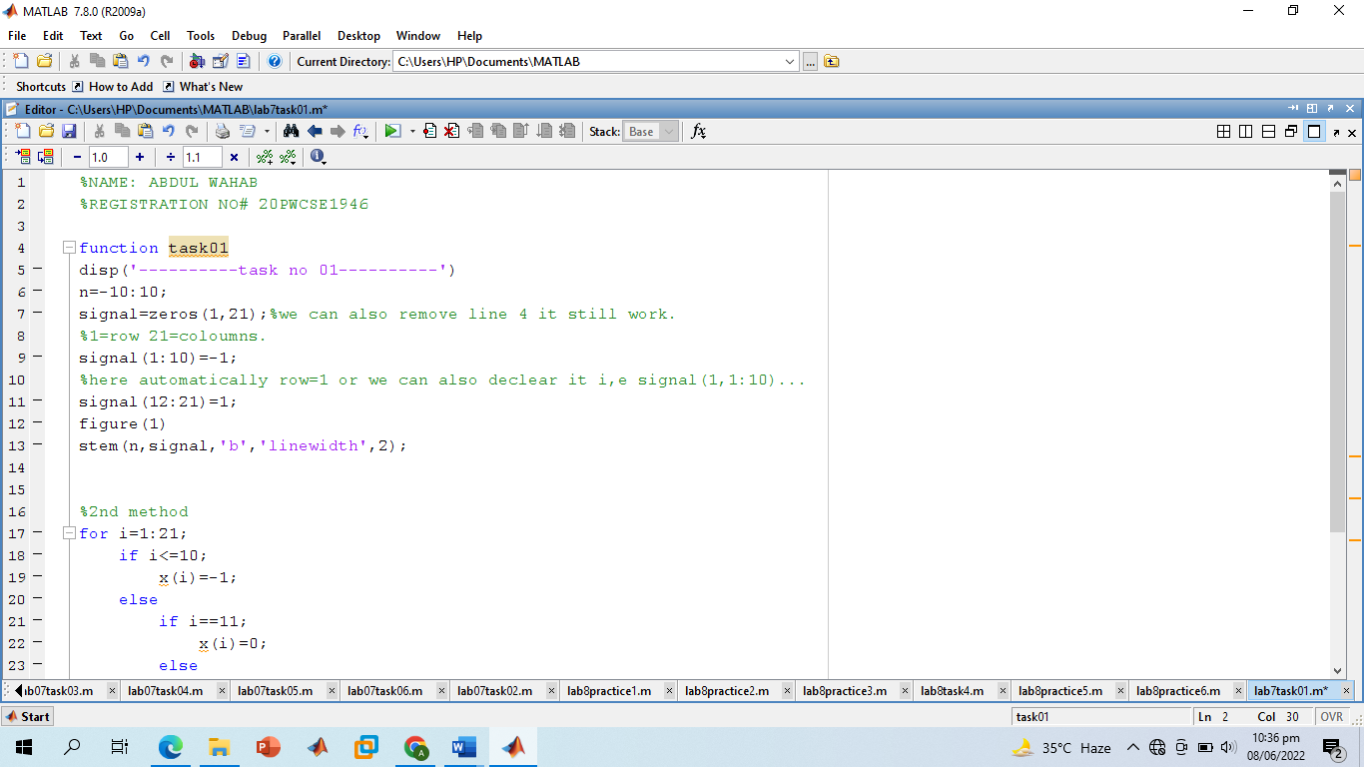

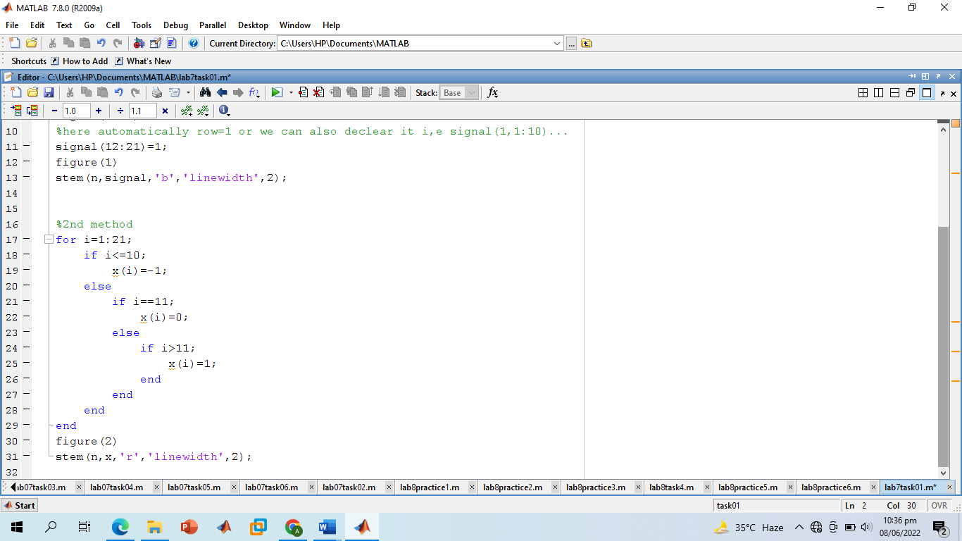

**Screenshot of Output:**

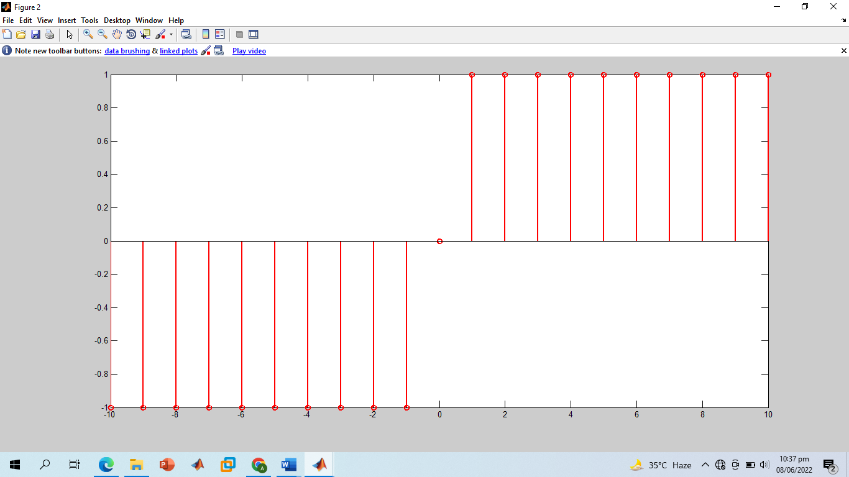

**-------------------------TASK 02-------------------------**

* Prove the following:

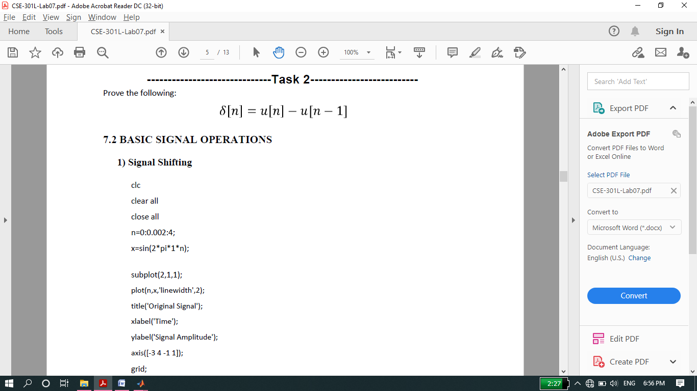

**Screenshot of Input:**

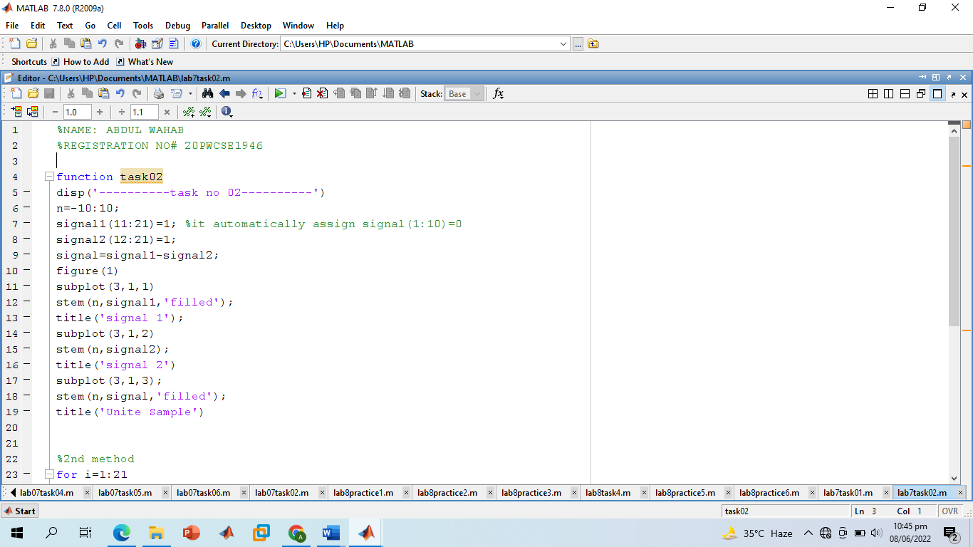

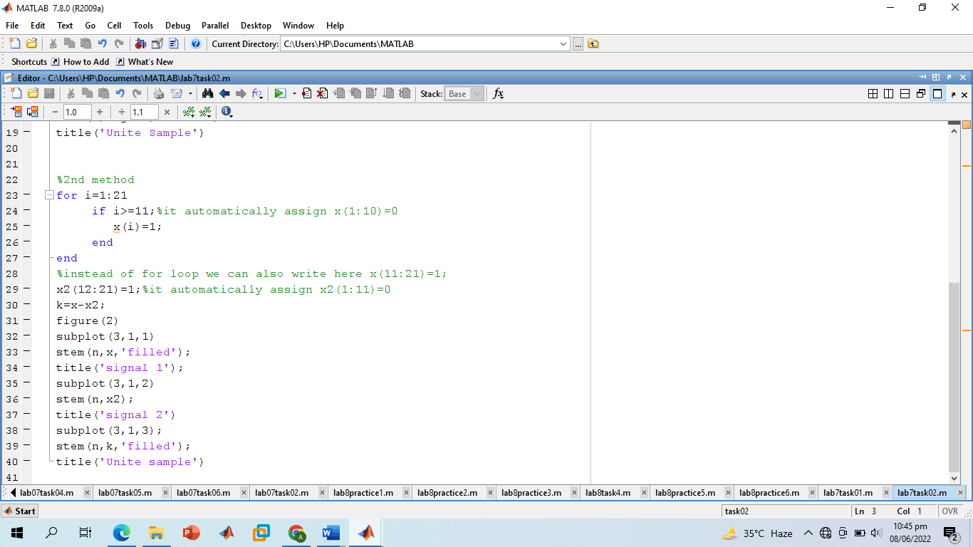

**Screenshot of Output:**

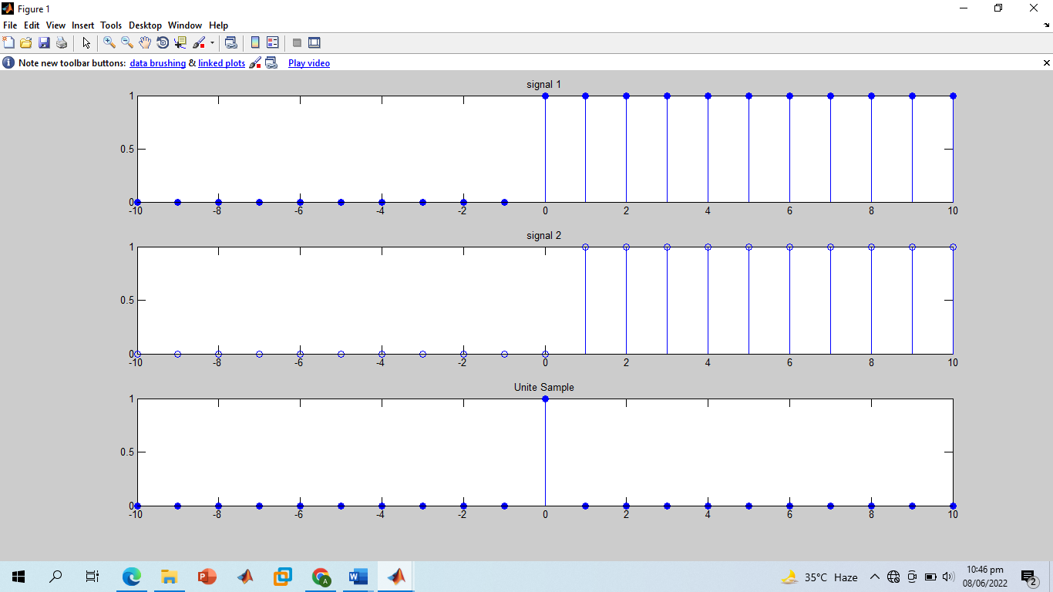

**-------------------------TASK 03--------------------------**

* Delay the **original signal** given in above example by 1 sec. Plot both the delayed & original signal on the same figure.

**Screenshot of Input:**

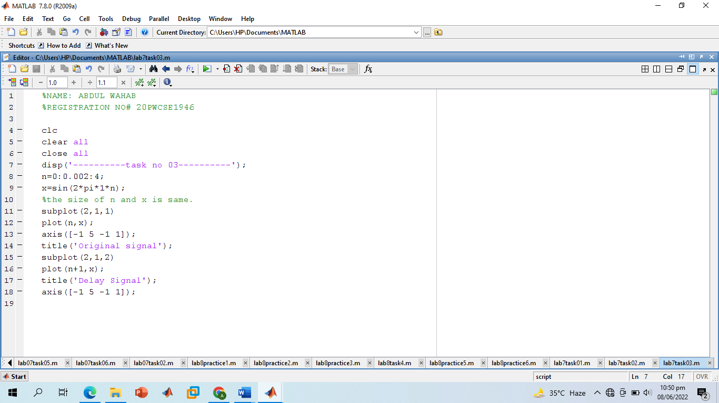

**Screenshot of Output:**

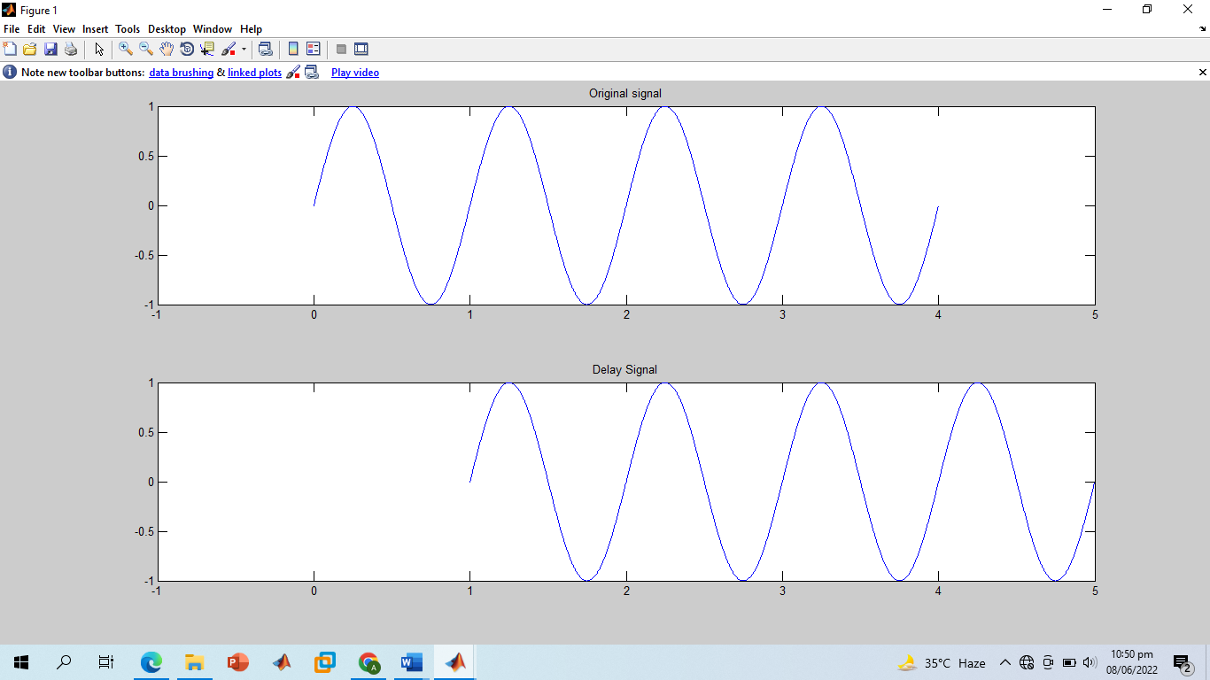

**-------------------------TASK 04--------------------------**

* Flip the following signal:

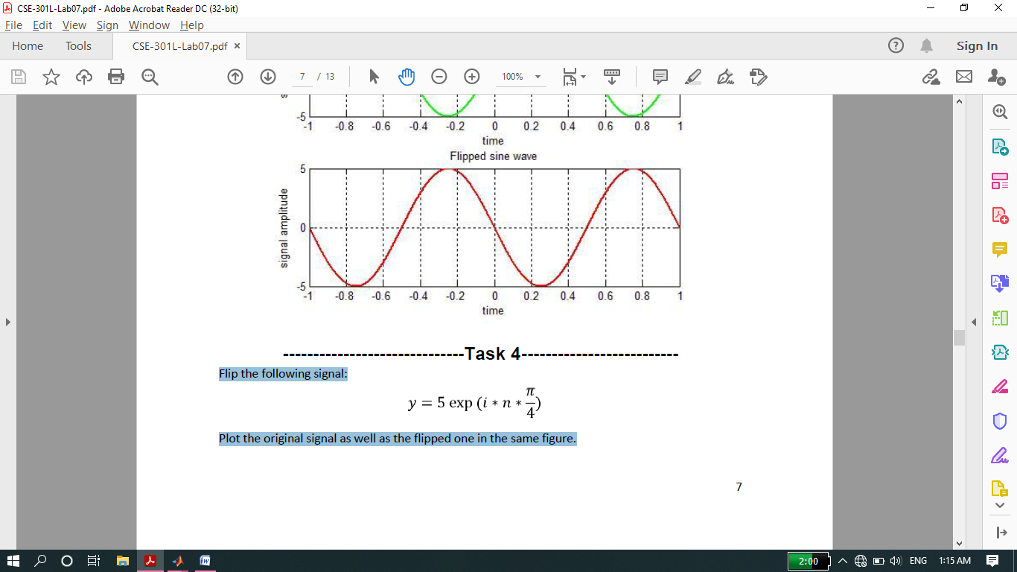

* Plot the original signal as well as the flipped one in the same figure.

**Screenshot of Input:**

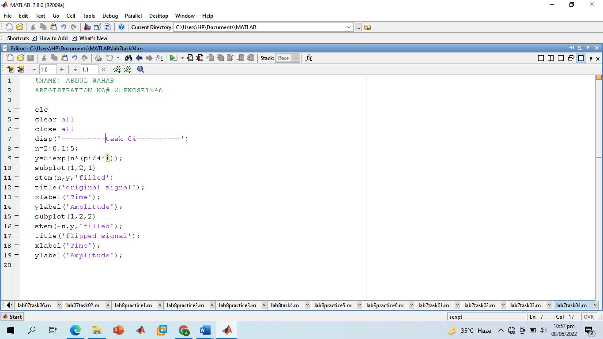

**Screenshot of Output:**

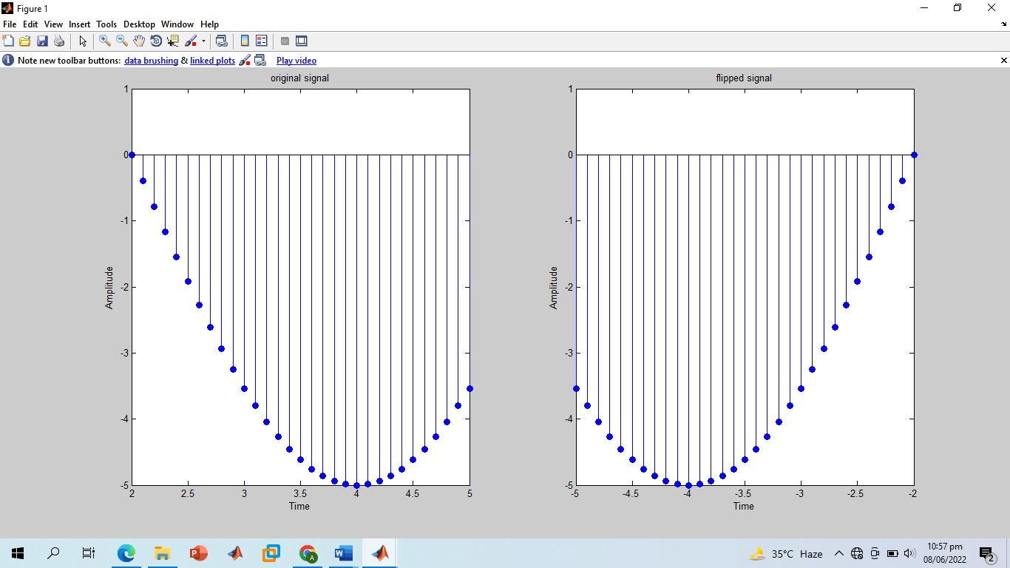

**-------------------------TASK 05--------------------------**

* Flip the following signal:

x[n]= 2δ[n]+ 5δ[n‐1] + 8δ[n‐2] + 4δ[n‐3] + 3δ[n‐4]

* Plot the original signal as well as the flipped one in the same figure.

**Screenshot of Input:**

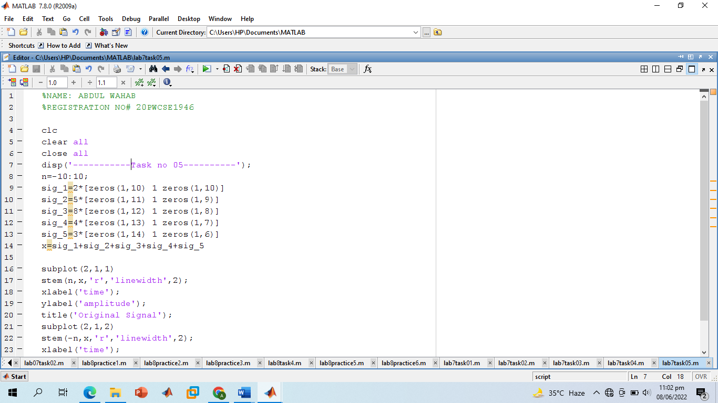

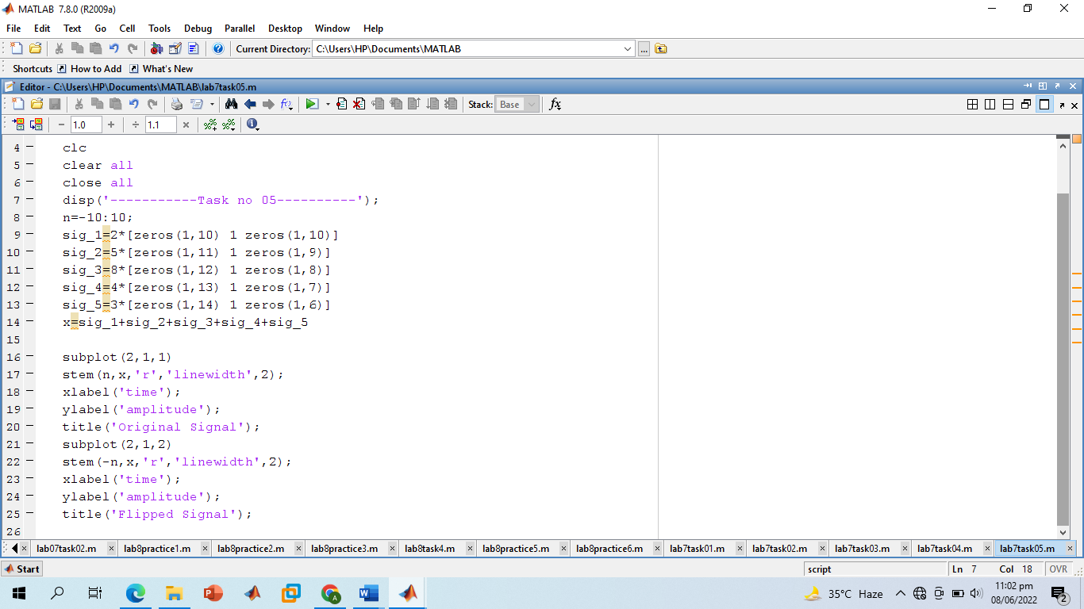

**Screenshot of Output:**

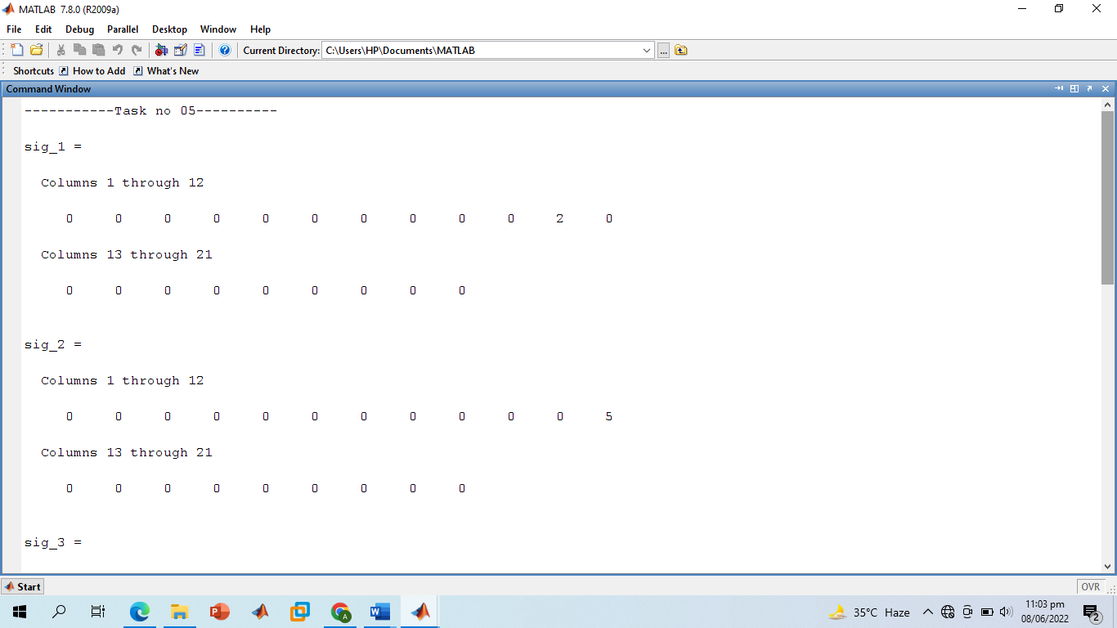

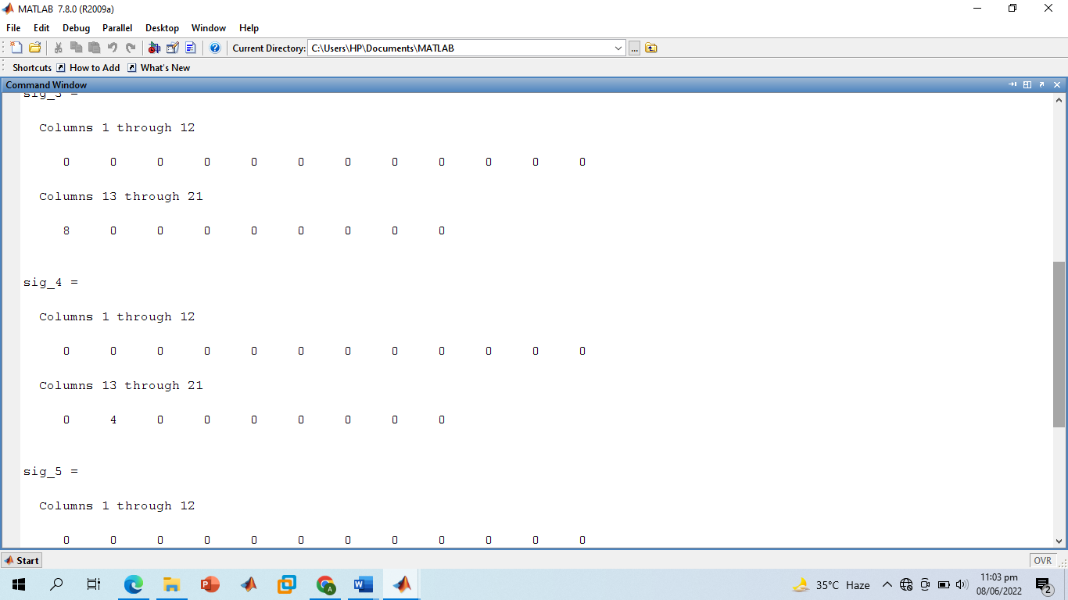

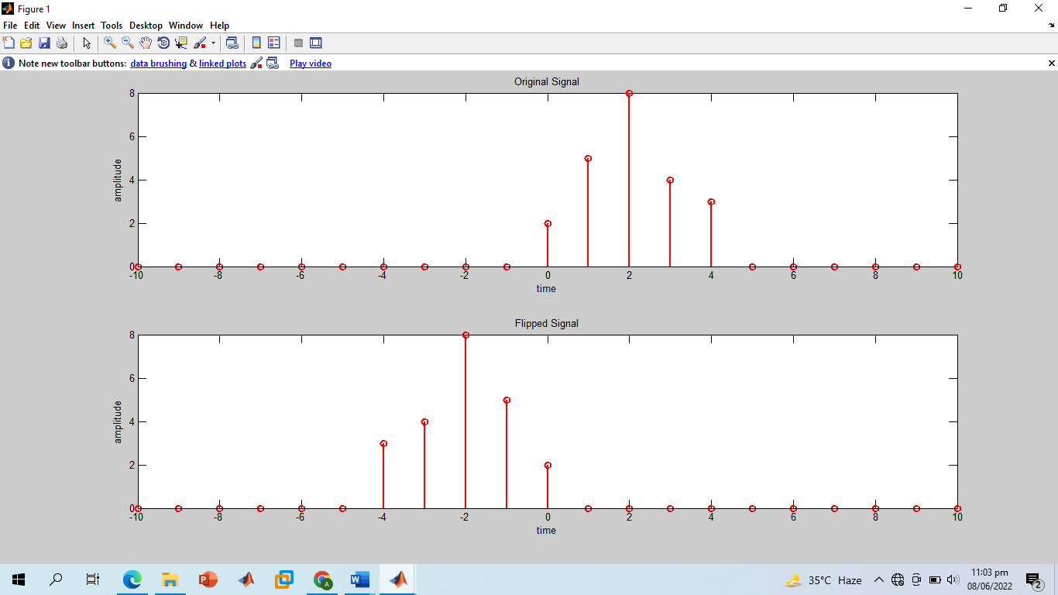

**-------------------------TASK 06--------------------------**

* Scale the continuous‐time sinusoid used in signal shifting example by a factor of 2.

**Screenshot of Input:**

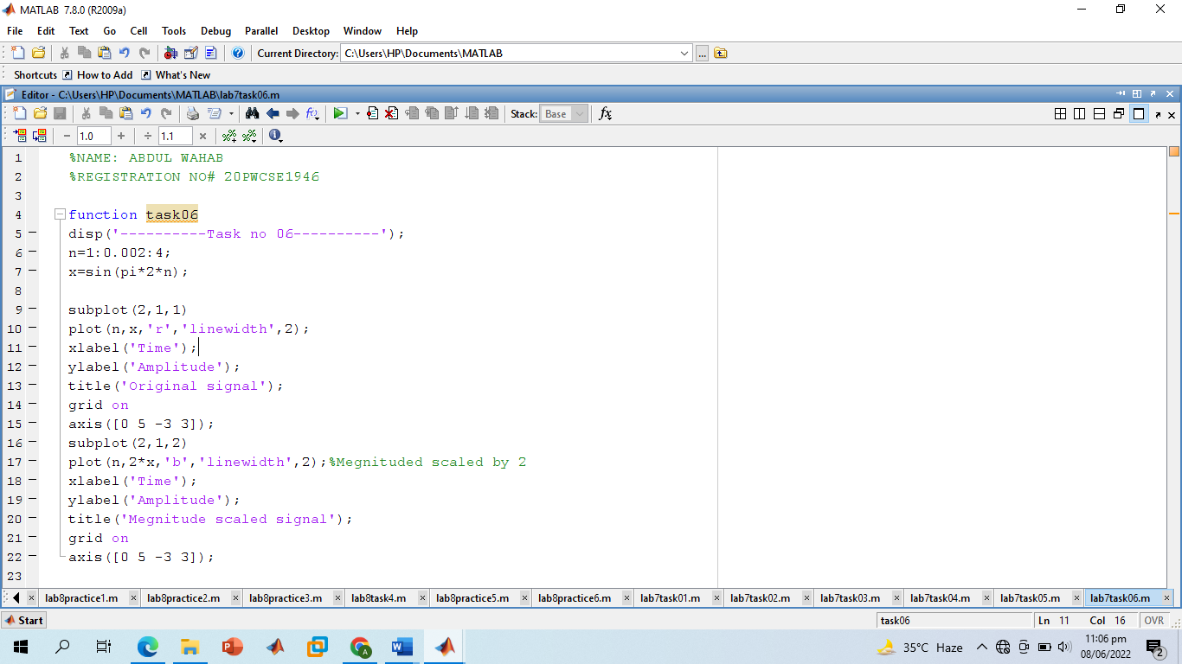

**Screenshot of Output:**

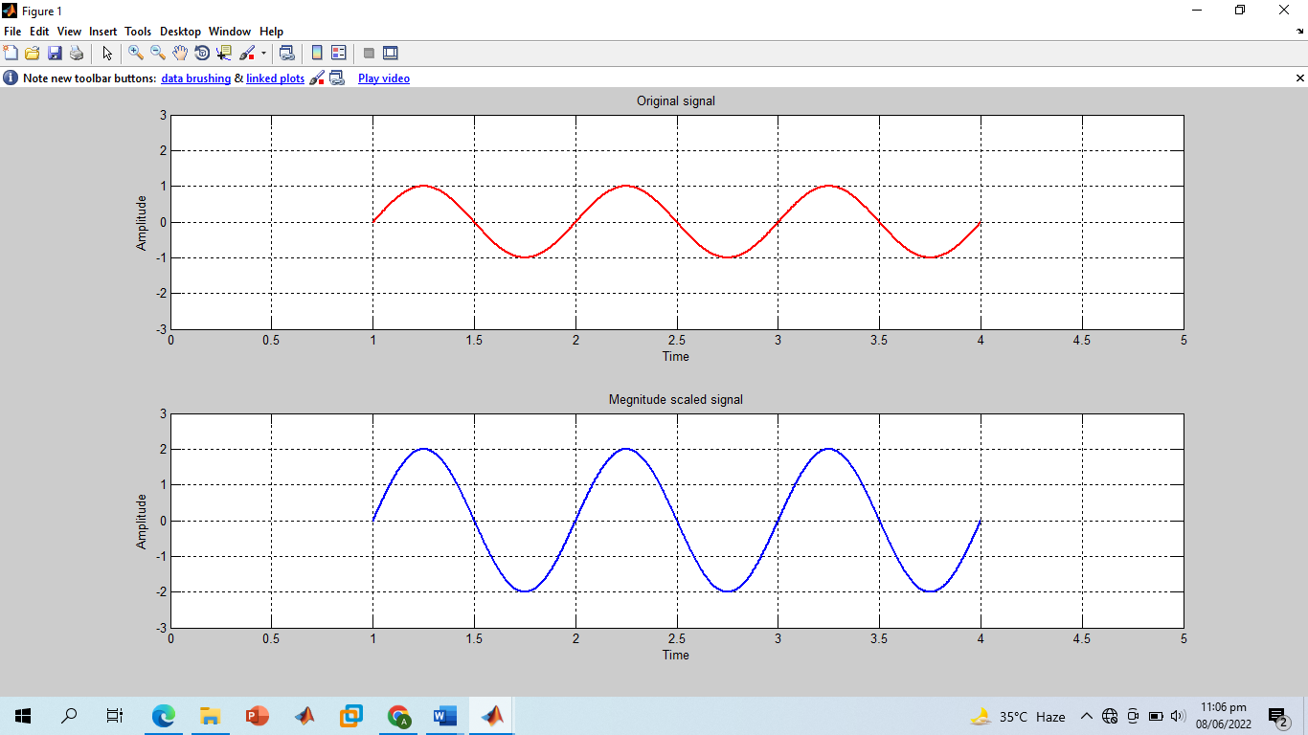

**-------------------------TASK 07--------------------------**

* Use ***interp*** command in the above program to interpolate (up‐sample) the signal by a factor of 2.

**Screenshot of Input:**

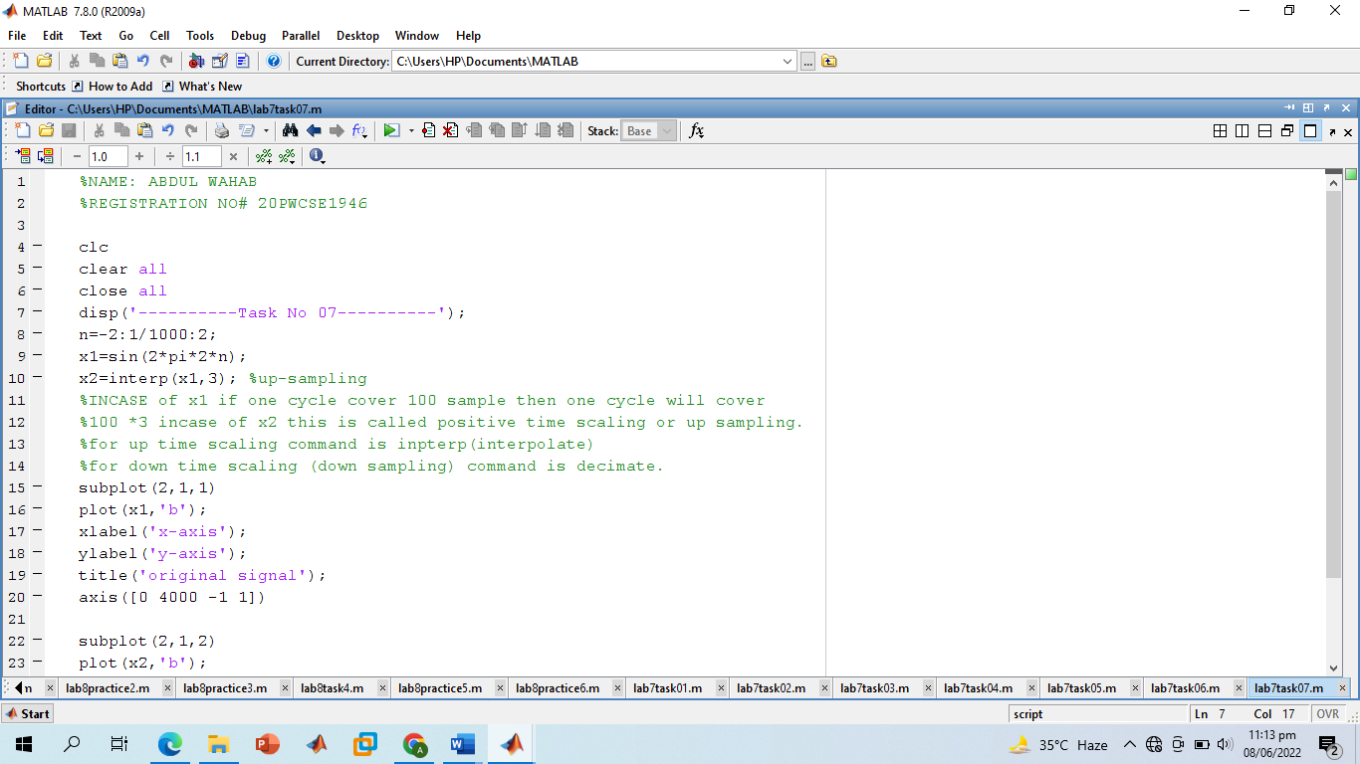

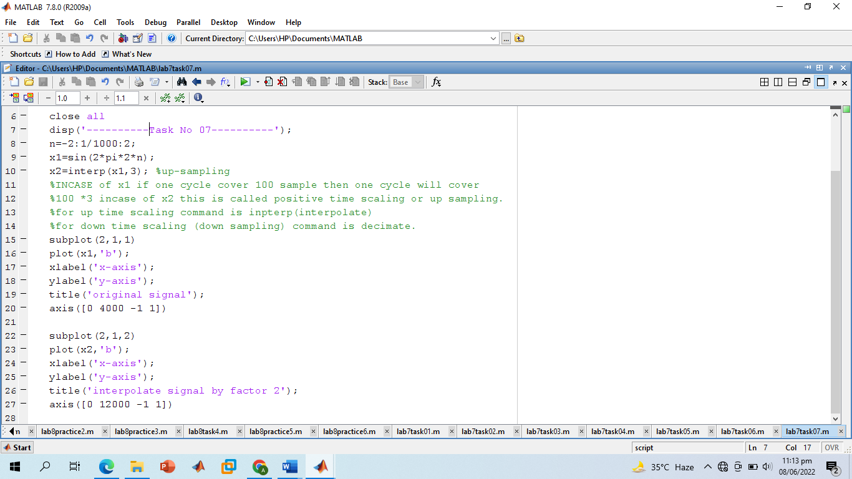

**Screenshot of Output:**

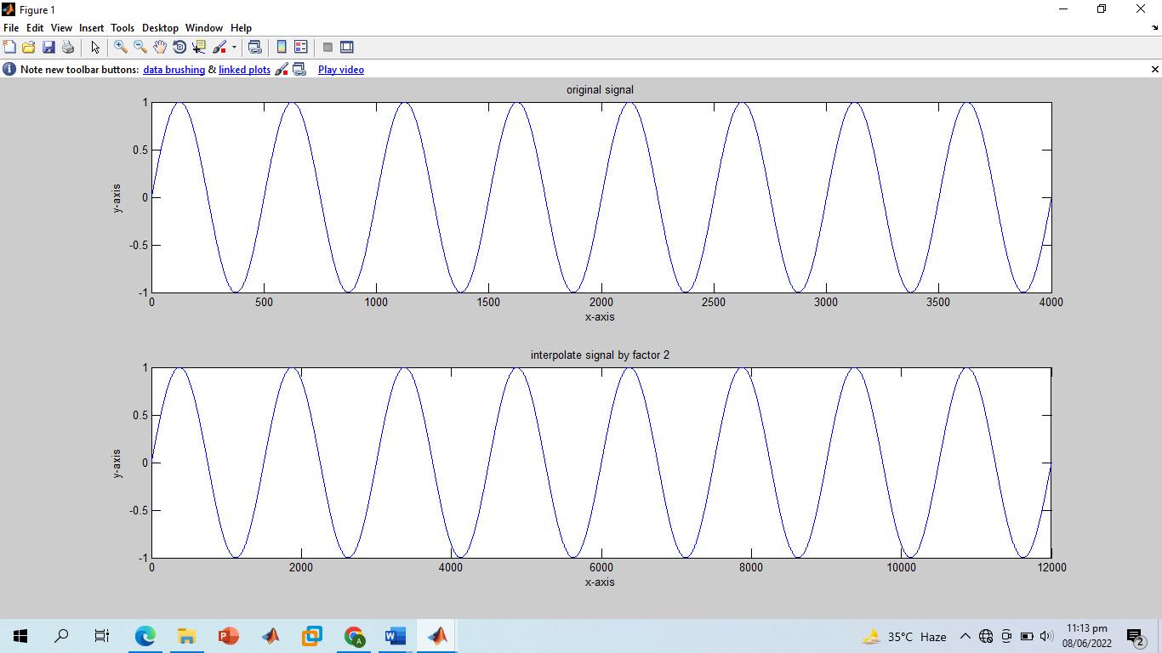

**-------------------------THE END! ---------------------------**